Software Requirements Specification

for

Wilderness Weather Station

Version 1.0 approved

Prepared by Tausif Sadid

BRACU CSE470

8th February 2019

# Preface

## Purpose

The purpose of this software is to provide a platform for collecting data for a wilderness weather station and then process and analyze this which can later be used for further research

## Product Scope

The intention of the software is to aid the wilderness weather stations to be implemented to help monitor climate change and to improve the accuracy of weather forecasts in remote areas.

# Introduction

## About the product

The software will be used to monitor and provide a constantly working and updated database of temperature and pressure, sunshine, rainfall, wind speed, and wind direction. The data collected will then undergo processing and analysis. The software will be very simple to use and functional. It will keep a database of all the values, after it undergoes all processing, and will be viewable by anyone accessing the software. The data collection will be done by using battery powered machinery which will then be implemented into the software every hour and the software will always be ensured to be compatible with newer machinery and provide constant updates to make the software easily useable and ensure maximum up-time of the software.

# User Requirement Definition

## Functional Requirements

* The data collected will be updated every hour and the updated temperature will be available for the user.
* All the data collected each hour will be kept in a log file which will also be able to be viewable by the user
* Wind speed and direction, ground and air temperature, sunshine, barometric pressure and rainfall will be monitored and these data will be available in the software
* All data will have an accuracy of 0.1 units.
* Temperature will be shown in Degrees Celsius, wind speed will be measured in knots, barometric pressure will be measured in millibars, sunshine measured in watts per square meter and rainfall in terms of millimeters
* Local processing and aggregation of data will take place before the data reaches the software from each weather station.
* Instruments, power and communication hardware will constantly be monitored and checked along with backups available on the go if something unexpected occurs.
* Newer versions of the software will be ensured to be compatible with the machinery.

## Non Functional Requirements

* The wilderness weather station software will be compatible with Windows OS.
* The software will undergo weekly patch updates of small or big changes depending on bug reports, technical difficulties and compatibility issues with new or old machinery and new features.
* The size of the software will be of less than 1GB of memory.
* The software will have a downtime of no more than 10 minutes.
* The software will automatically indicate if there are any anomalous values such as temperatures over 65 degrees Celsius and this will prevent false values being inputted into the database.
* The response time of providing the data and the data being visible by anyone else accessing the database will be less than 0.2 seconds.
* The data will initially go to the local server and from here there will be three backup servers storing the same data in case of a failure to retrieve data from the main server.
* In a situation where the main server cannot provide a response within a period of 0.1 seconds, the connection will automatically be routed to one of the backup servers which will temporarily act as the main server.
* The software will have a very simple user interface which can be easily accessible and understandable.

# System Architecture

## UML Diagrams

1. Use Case Diagram

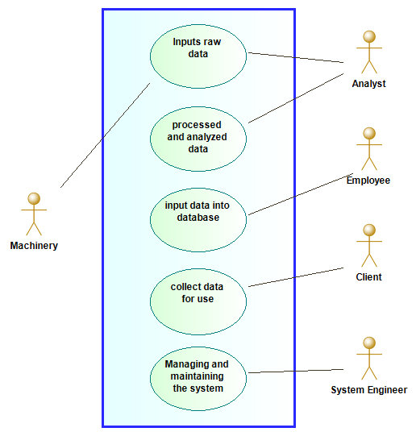

1. Activity Diagram

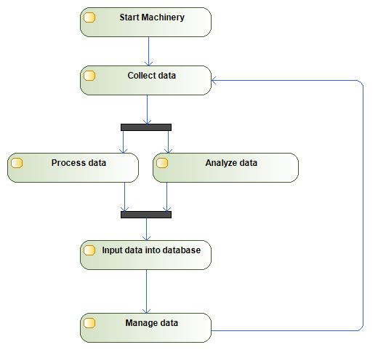

1. Sequence Diagram

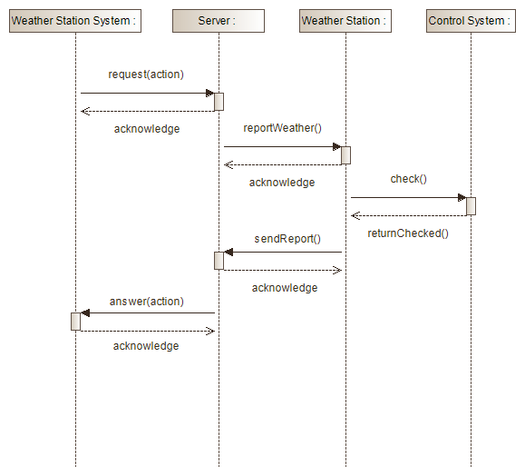

# System Requirement Specification

As mentioned above in the functional requirements, the data will be updated every hour. It is not monitored more often as the values of all the variables to be collected will not vary much in a time less than an hour. The data collected will all be kept in a log file to help in tracking any bugs and errors while using the software to be patched in later versions. All data collected will have an accuracy of 0.1 ensuring liability and precision of data for a more accurate representation of the data over time. The data collected will all be in standard values of representation as mentioned above. The software will always be ensured to be updated to be compatible with any new machinery and all existing machinery all the time.

For the non functional requirements, MAC OS and other platforms will be implemented as soon as possible and if possible to as many platforms as possible. Weekly collection of bug reports and data will give the developers an idea of how to ensure the software to be as perfect as possible by pushing updates every week solving the bugs and crashes. The software will never have a downtime of more than 10 minutes, since data is collected every hour, any late than 10 minutes would delay the process leading to the next recordings to be delayed further and so on. To avoid this necessary steps will be taken such as providing multiple backup servers to retrieve and update existing data. The servers will be present not only on the data collection centers but also on the analysis and processing centers as well as the main office. Finally, the software user interface will be implemented in a manner so that it is easy to understand and accessible without little to no extra effort from the user.

# System Models

# Appendices